**CRM APPLICATION FOR JWELL MANAGEMENT DEVELOPER**

**COLLEGE NAME**: SHRI NEHRU MAHA VIDYALAYA COLLEGE OF ARTS AND SCIENCE.

**COLLEGE CODE:** BRU 26

**TEAM ID: NM2025TMID20581**

**TEAM MEMBERS:**

TEAM LEADER**:** VISHNU THIRUMALAIPATHY

**EMAIL**: [vishnupathy904@gmail.com](mailto:vishnupathy904@gmail.com) TEAM MEMBER: SERMADURAI.G

**EMAIL:** [sdhurai929@gmail.com](mailto:sdhurai929@gmail.com)

TEAM MEMBER**: M.THILOTHANA**

**EMAIL:** [**thilothana0@gmail.com**](mailto:thilothana0@gmail.com)

TEAM MEMBER**:RAVIKUMAR.R**

**EMAIL:** [**ravikumarravi635117@gmail.com**](mailto:ravikumarravi635117@gmail.com)

* 1. **INTRODUCTION**

**1.1 PROJECT OVERVIEW**

The Jewellery industry requires efficient management of customers, sales, inventory, and services. A **CRM (Customer Relationship Management) application** helps jewellery businesses streamline operations, maintain customer relationships, track sales, manage stock, and provide personalized experiences.This project focuses on building a **CRM application tailored for jewellery management**, providing a centralized platform for handling customers, employees, suppliers, and business activities.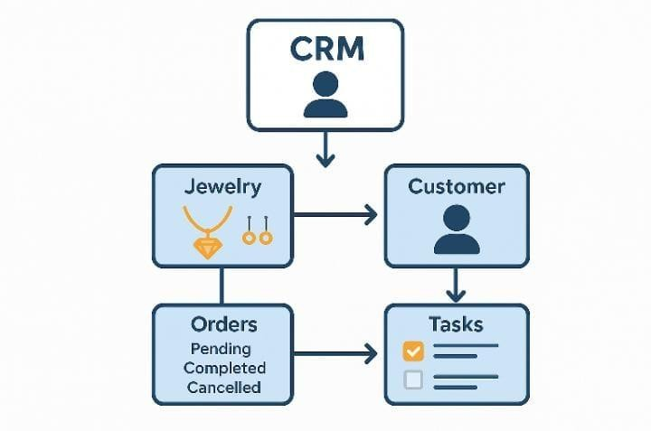

* 1. **PURPOSE**

The purpose of this project is to **streamline jewellery business operations** by providing a centralized **CRM solution** to manage customers, sales, billing, inventory, suppliers, and employees. It helps jewellery stores improve **customer relationships, reduce manual errors, track stock effectively, and generate real-time reports** for better decision-making and business growth.

**DEVELOPMENT PHASE**

**CREATING DEVELOPER ACCOUNT:**

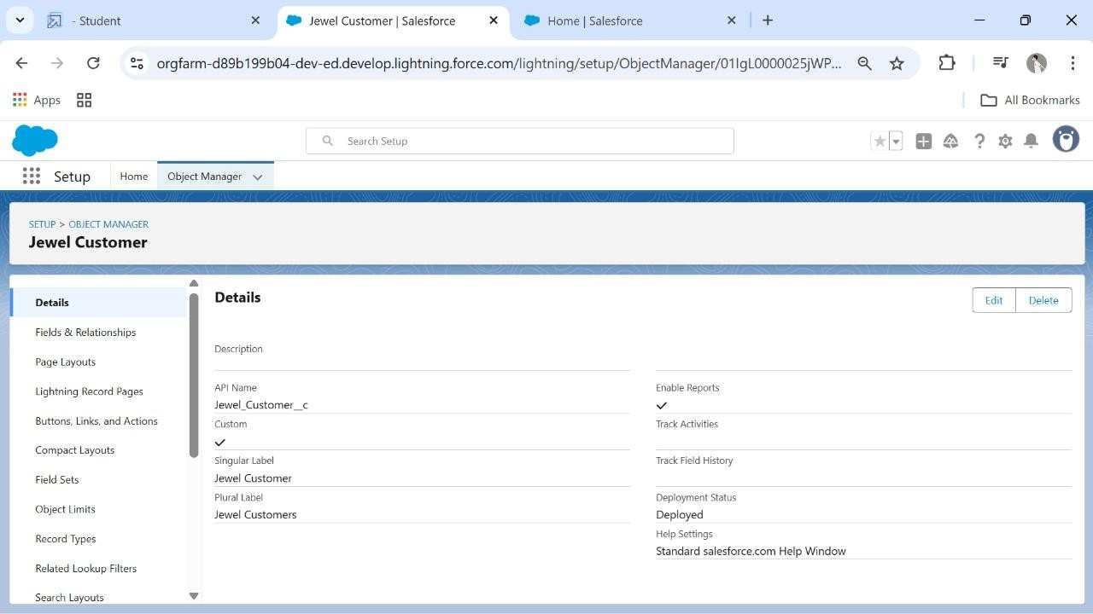By using this url: [https://www.salesforce.com/form/developer-](https://www.salesforce.com/form/developer-signup/?d=pb) [signup/?d=pb](https://www.salesforce.com/form/developer-signup/?d=pb)

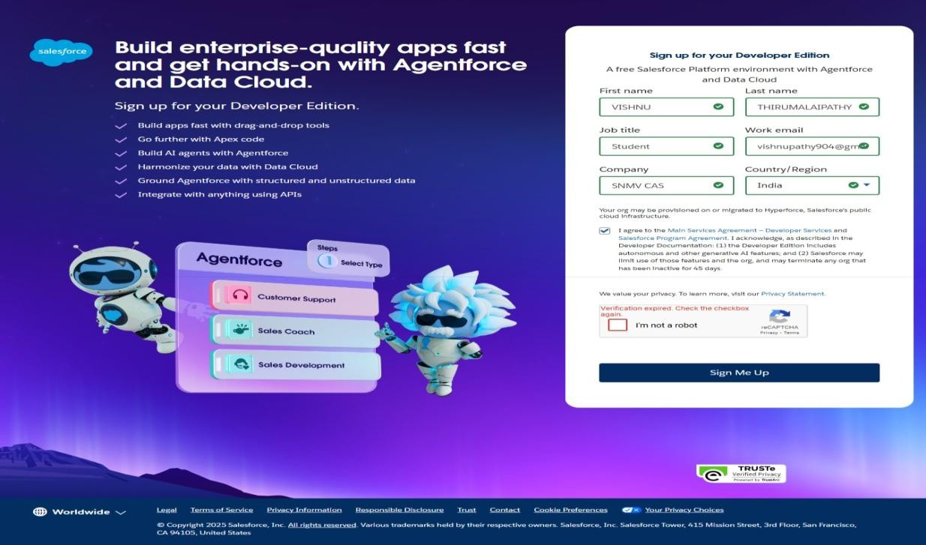

**Create a jwell customer object**

**OBJECTS**

CREATED OBJECTS:

* **ITEMS**
* **BILLINGS**
* **PRICES**
* **CUSTOMER ORDER**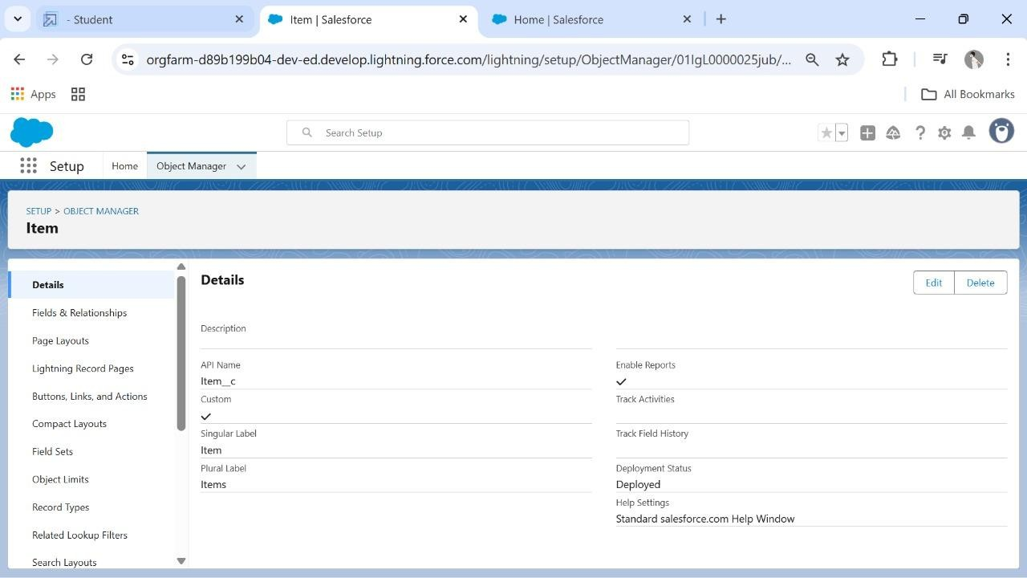

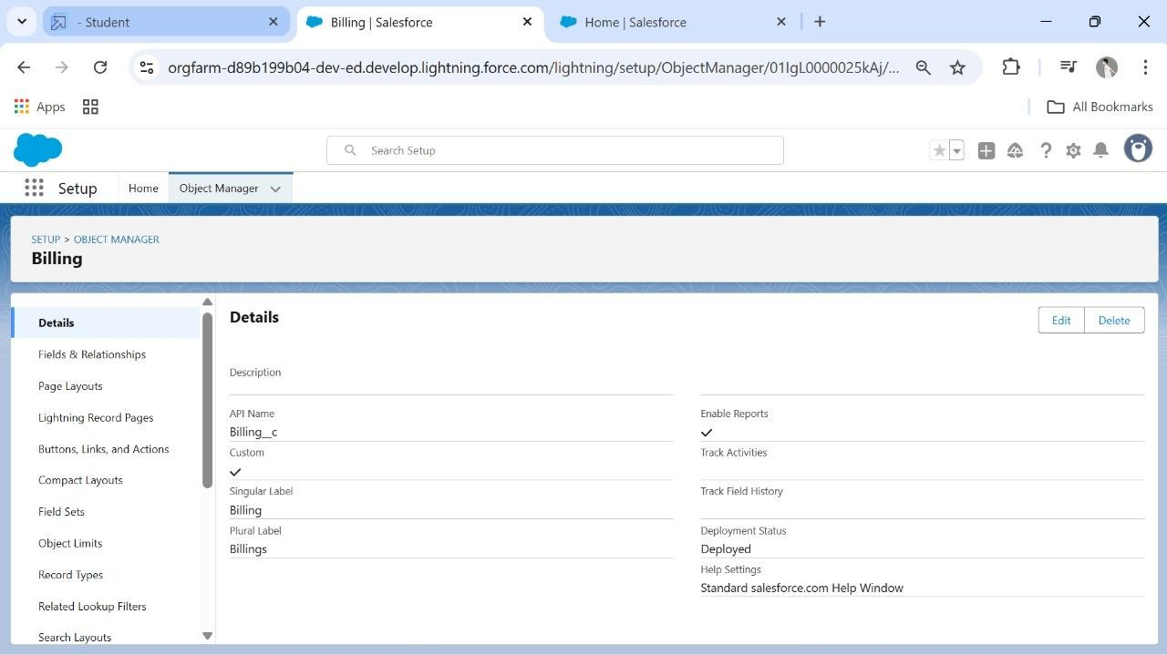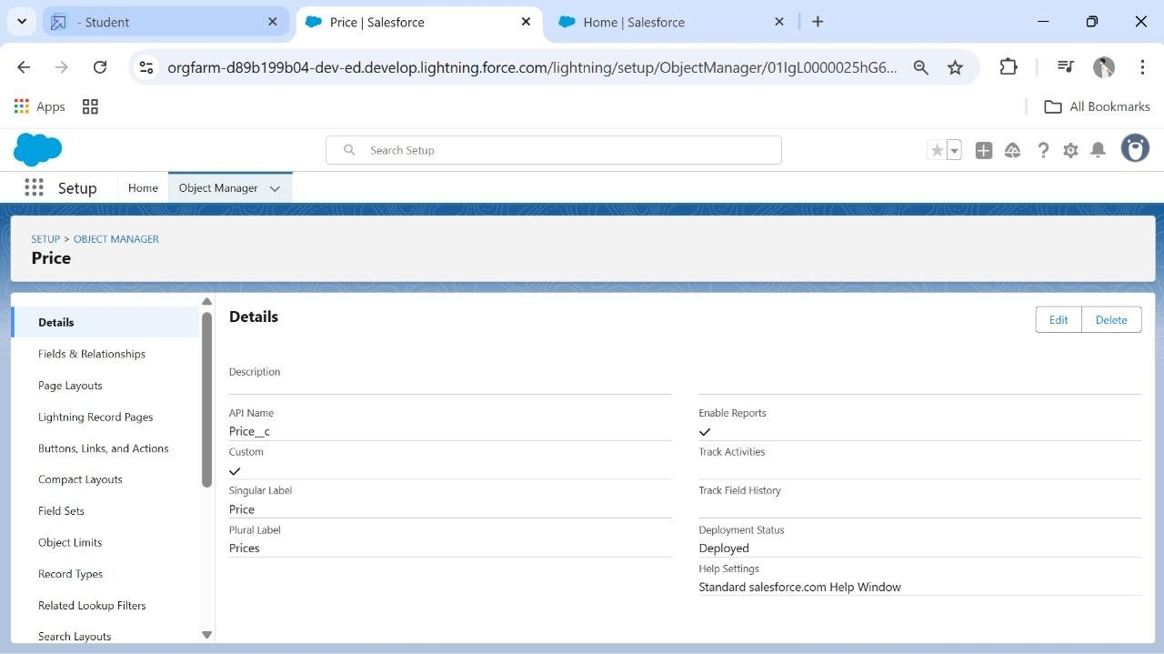

**CREATED TABS:**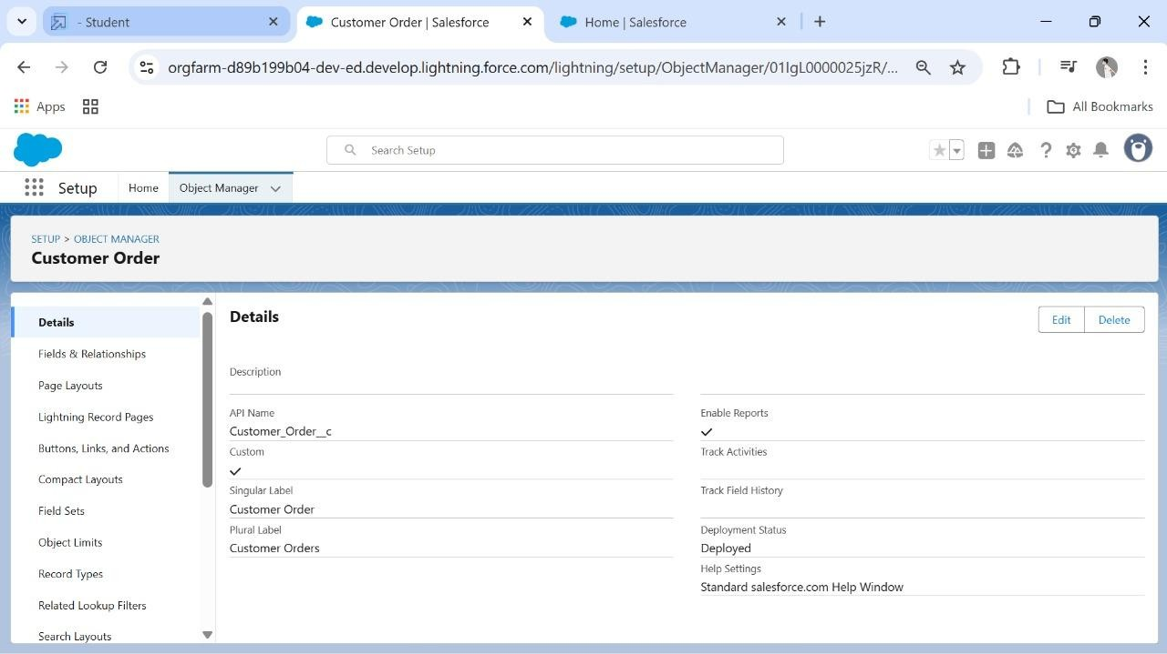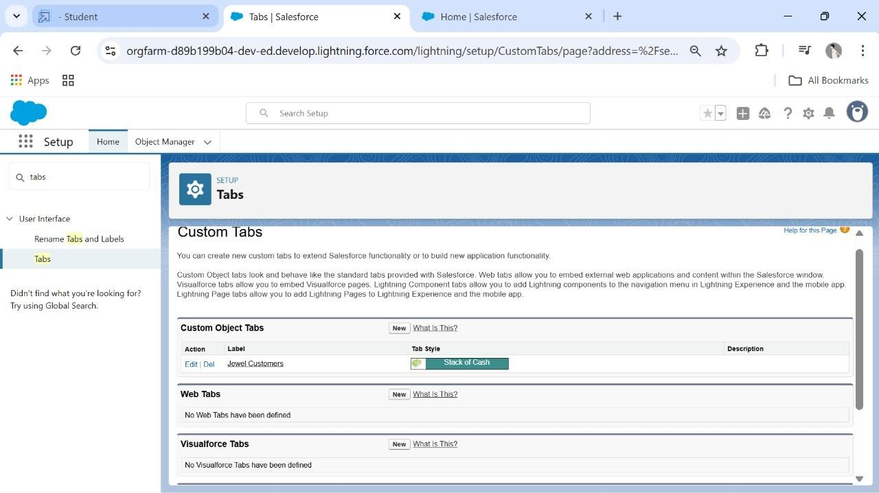

**Created A Tab:**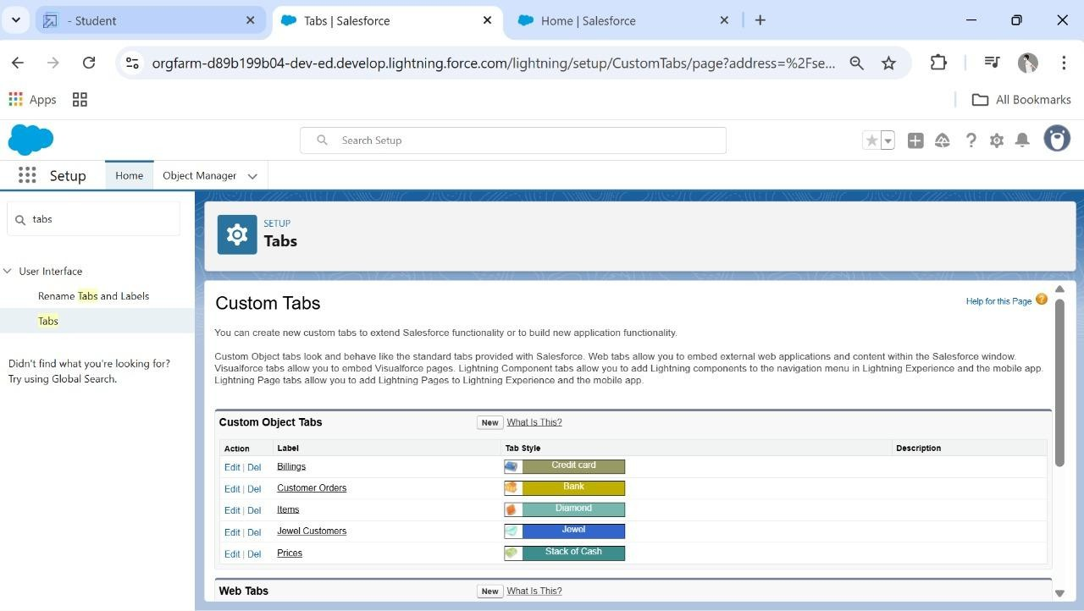

**Created A Lightning App:**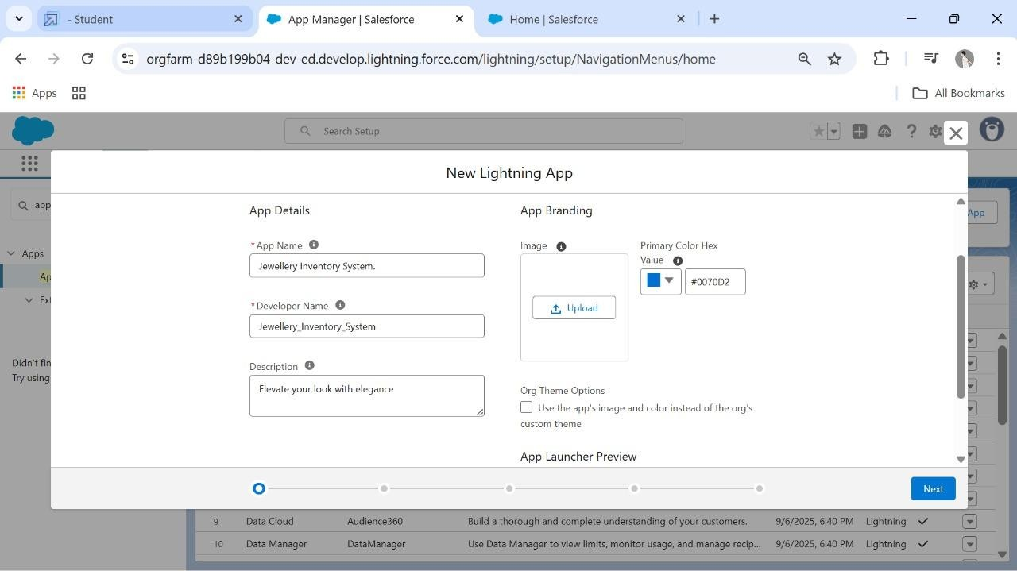

**Created Lookup Relationship:**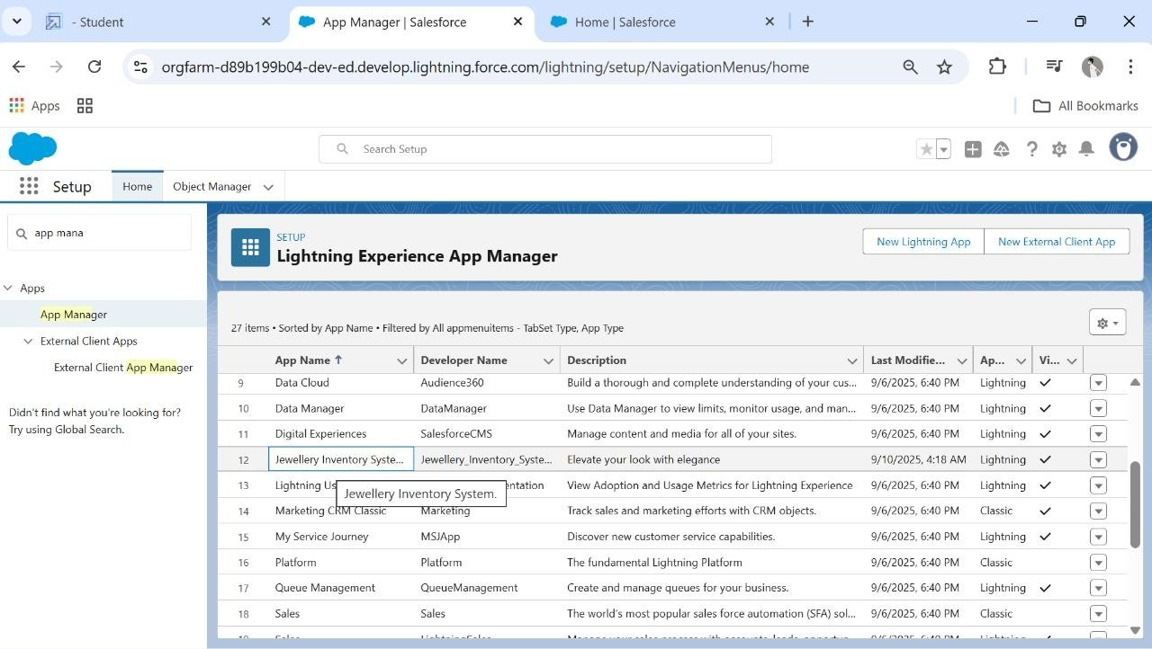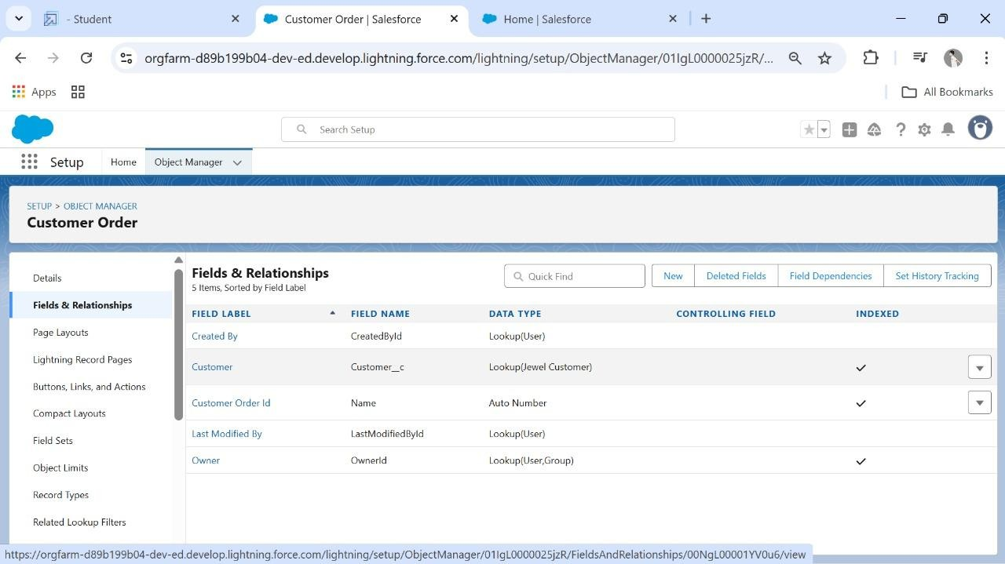

**Created Text, phone, Email Field In Jewel Customer Object:**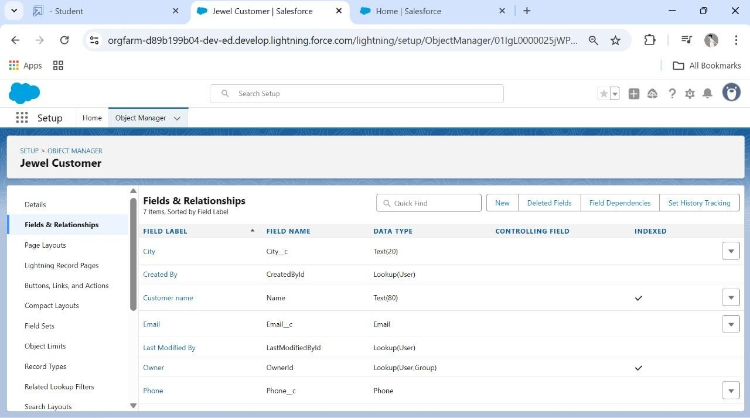

**Created The Number, picklist Field In Item Object:**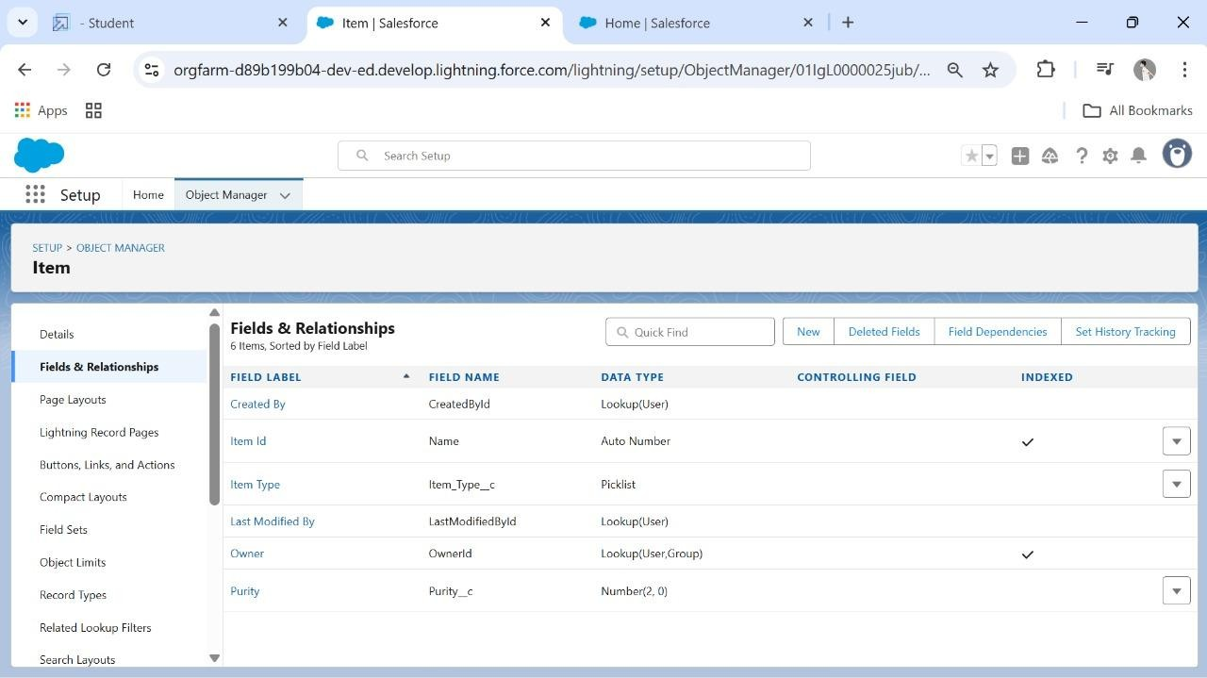

**Created Currency Field In Price Object:**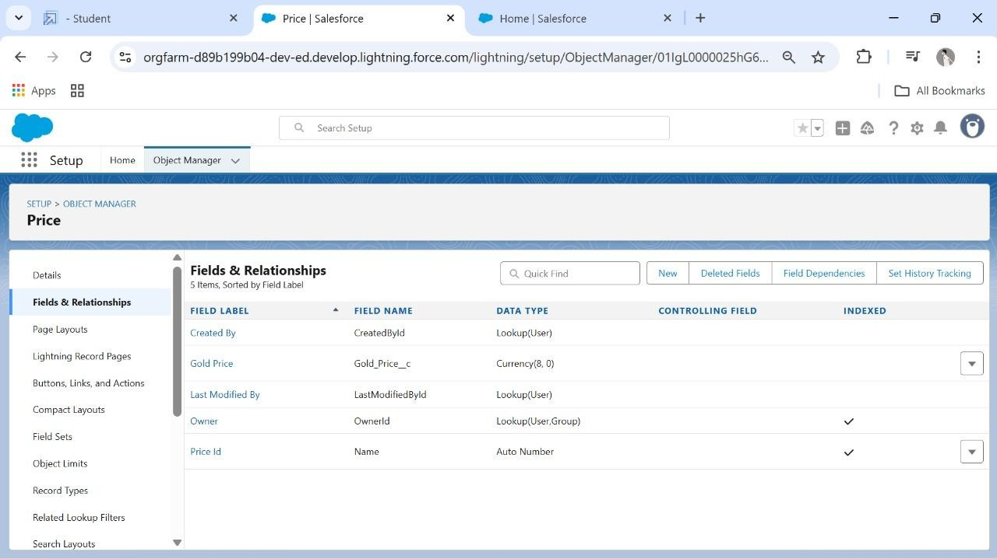

**Created Formula Fields:**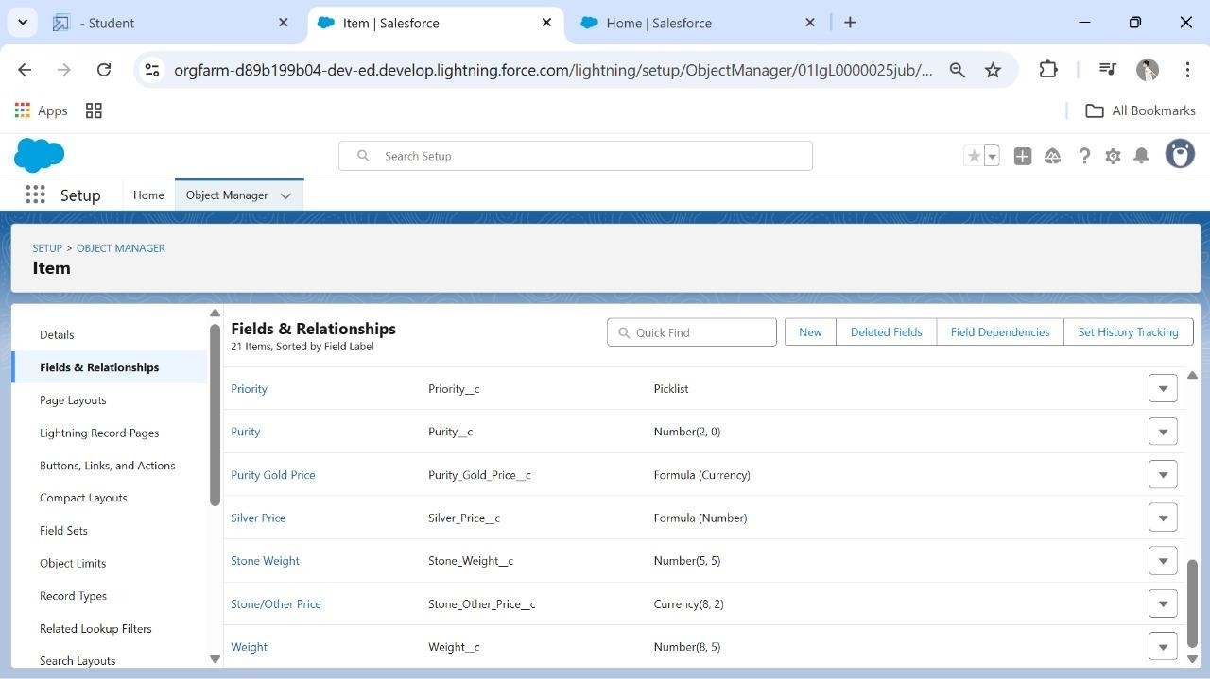

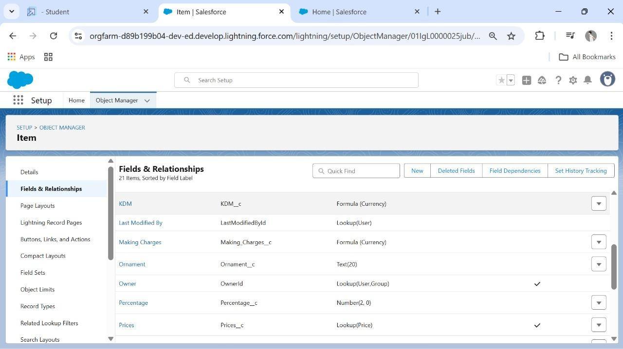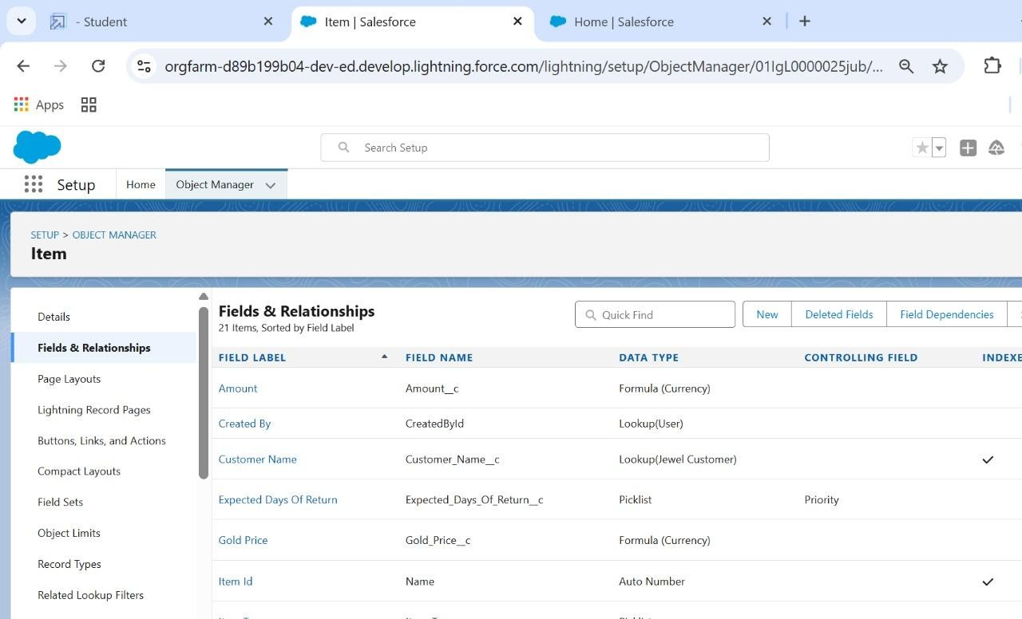

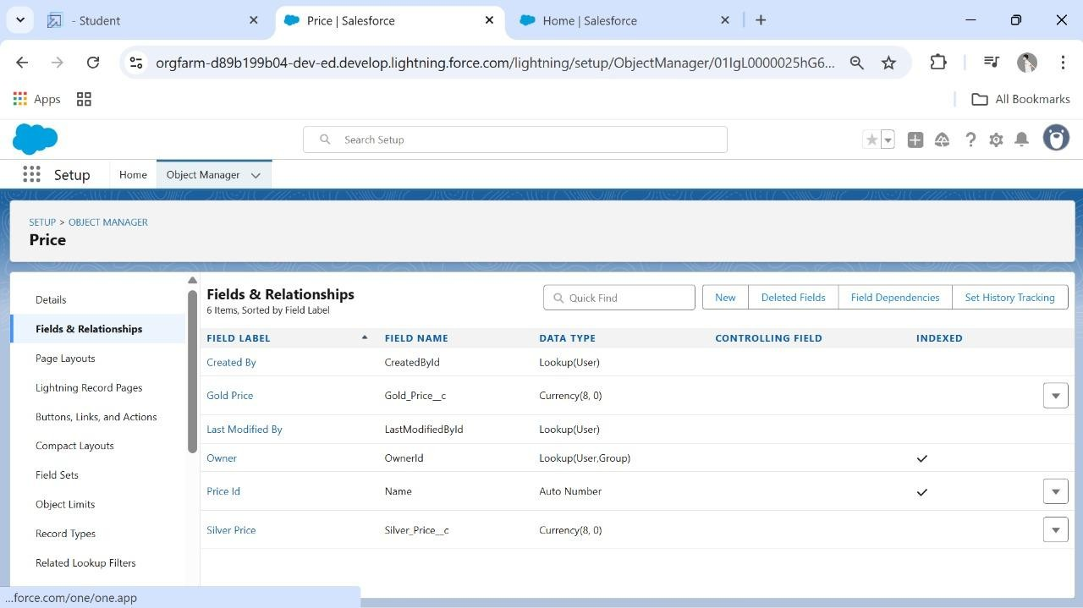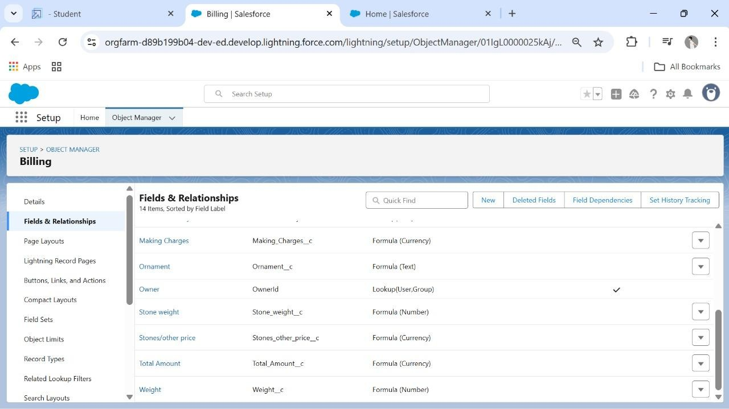

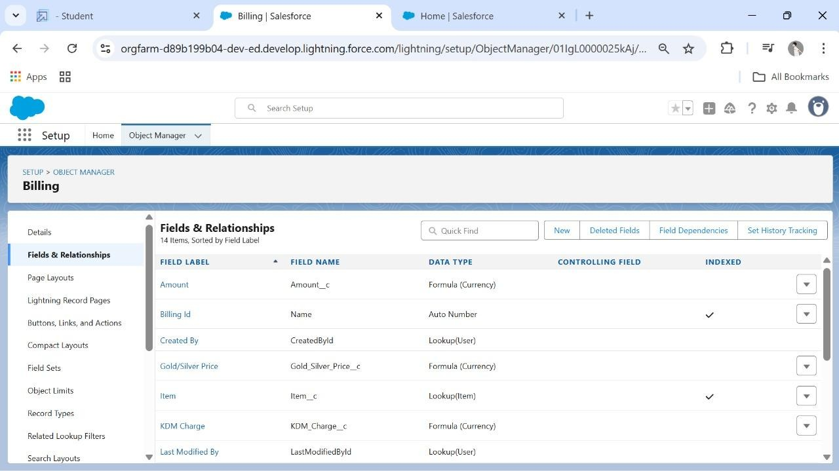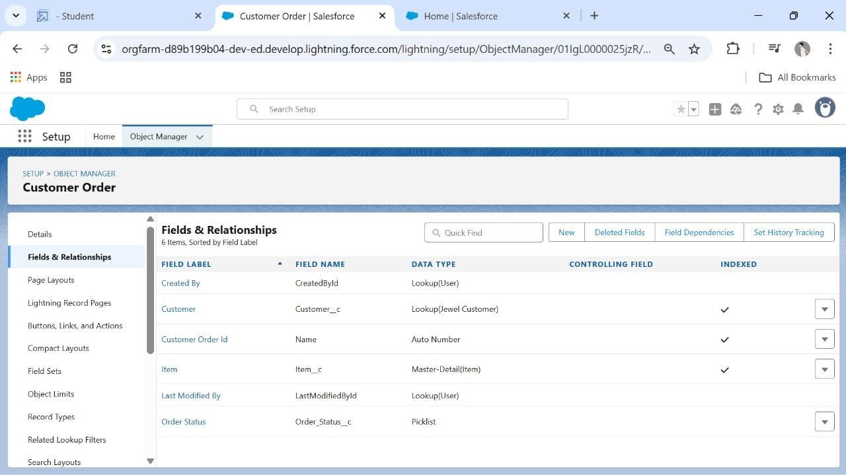

**Created The Field Dependencies** :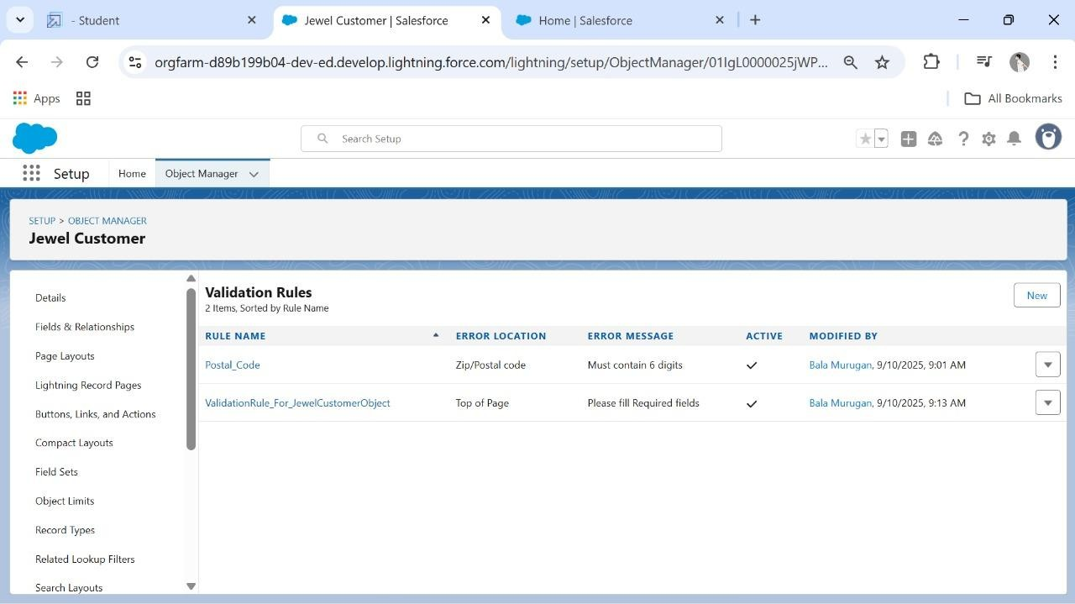

**Created The Validation Rule:**

**Profiles:**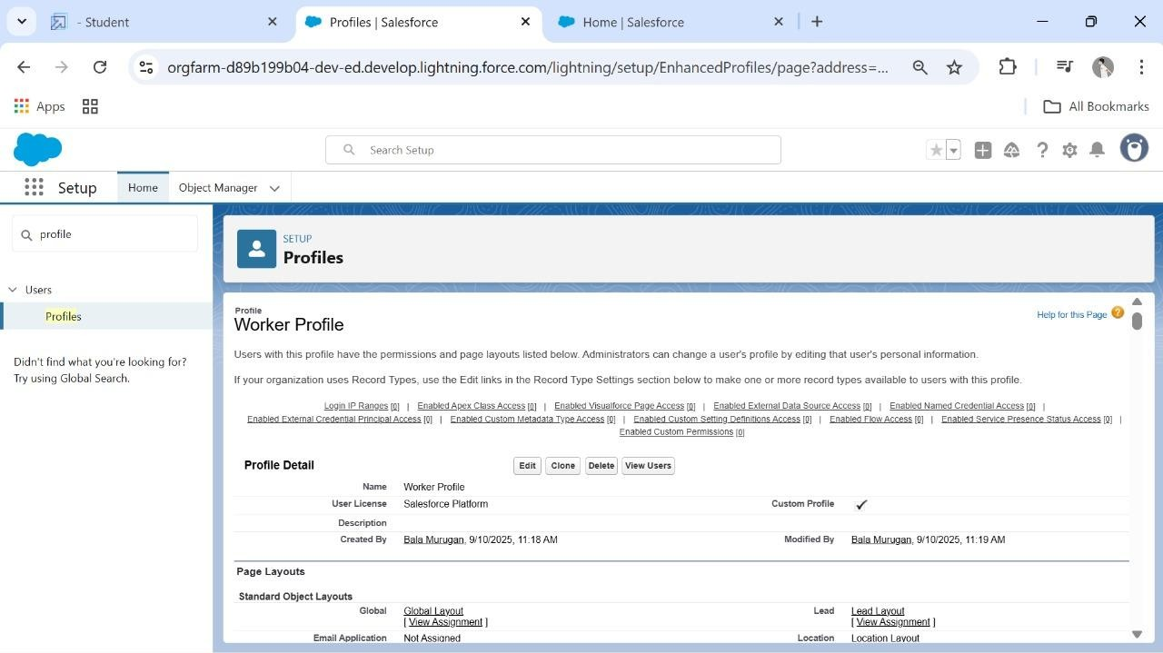

**Roles:**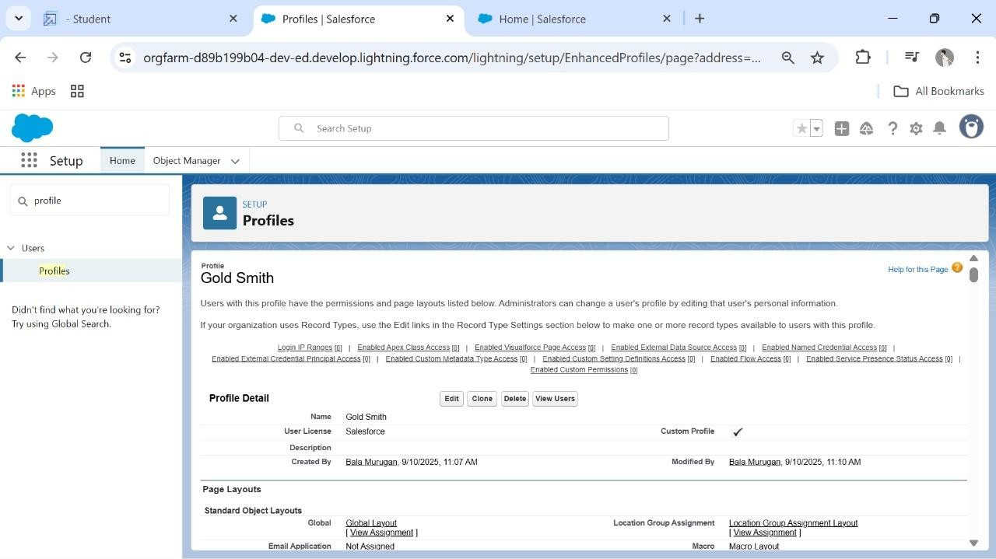

**Users:**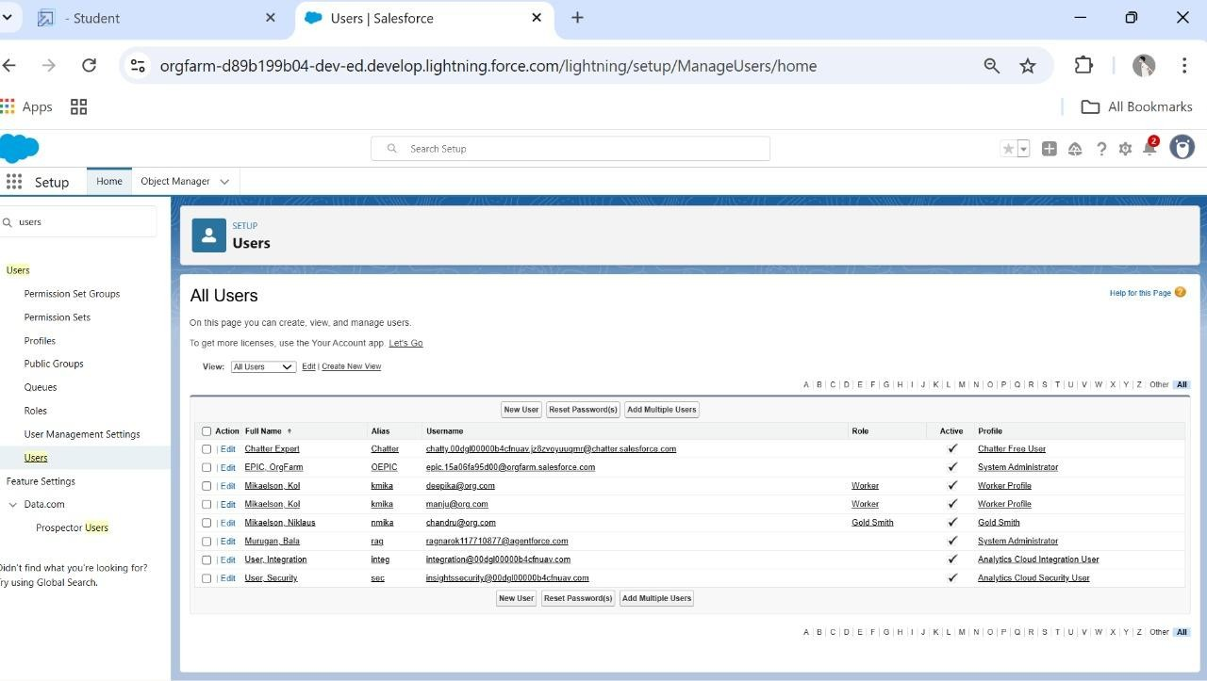

**Page Layouts:**

**Record Types:**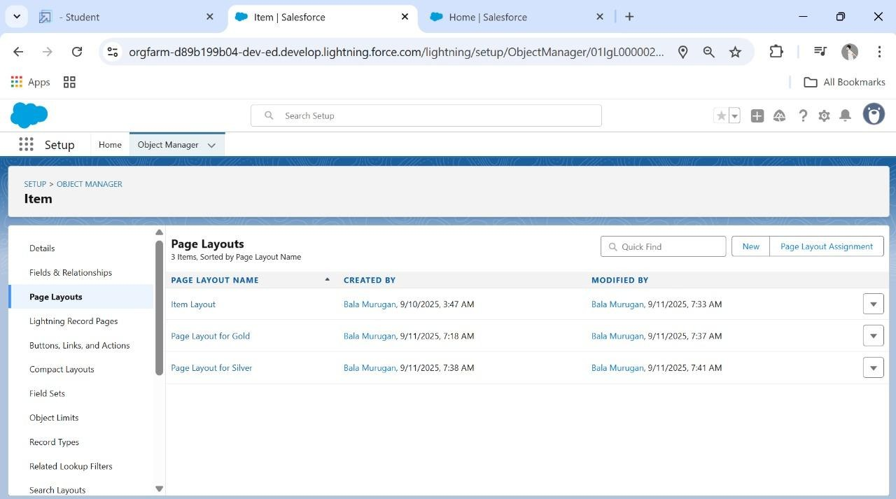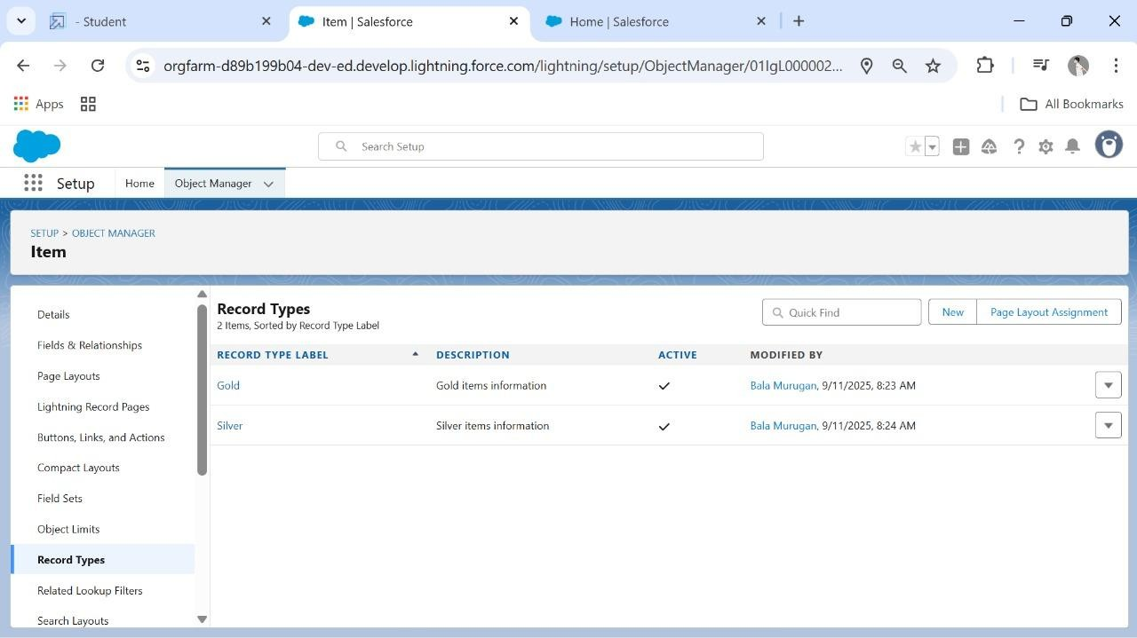

**Created Permission Set:**

**Created A Trigger Handler Class:**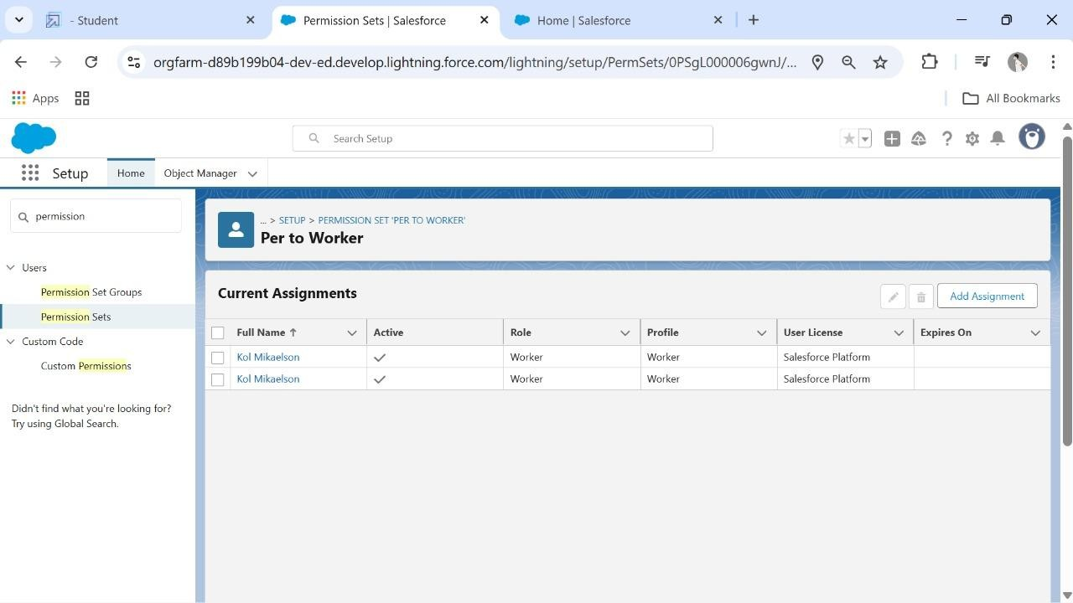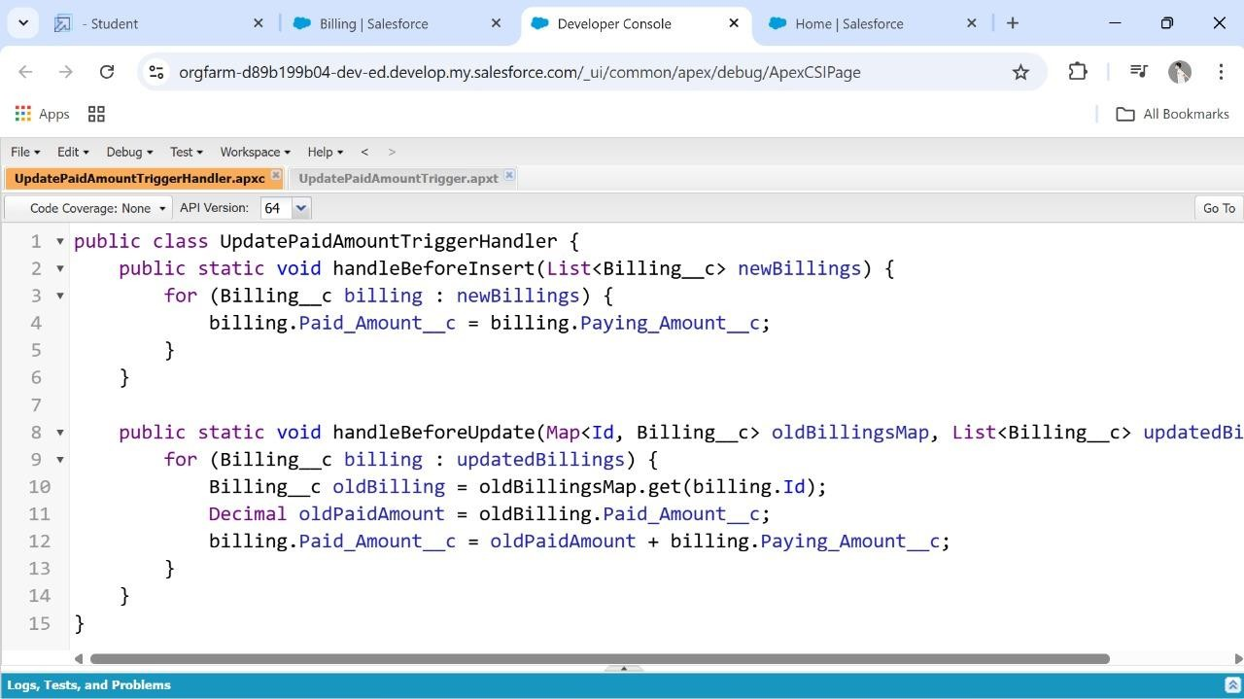

**Create The Trigger:**

**User Adoption, Reports, Create Dashboard:**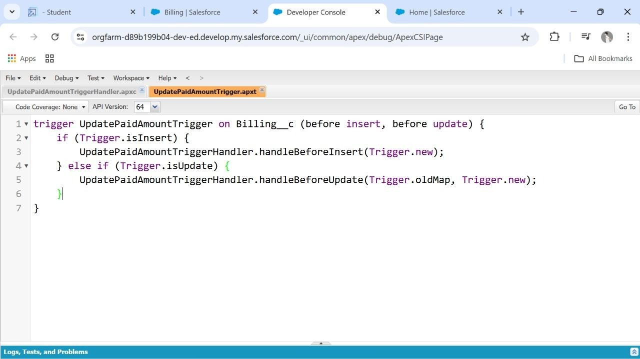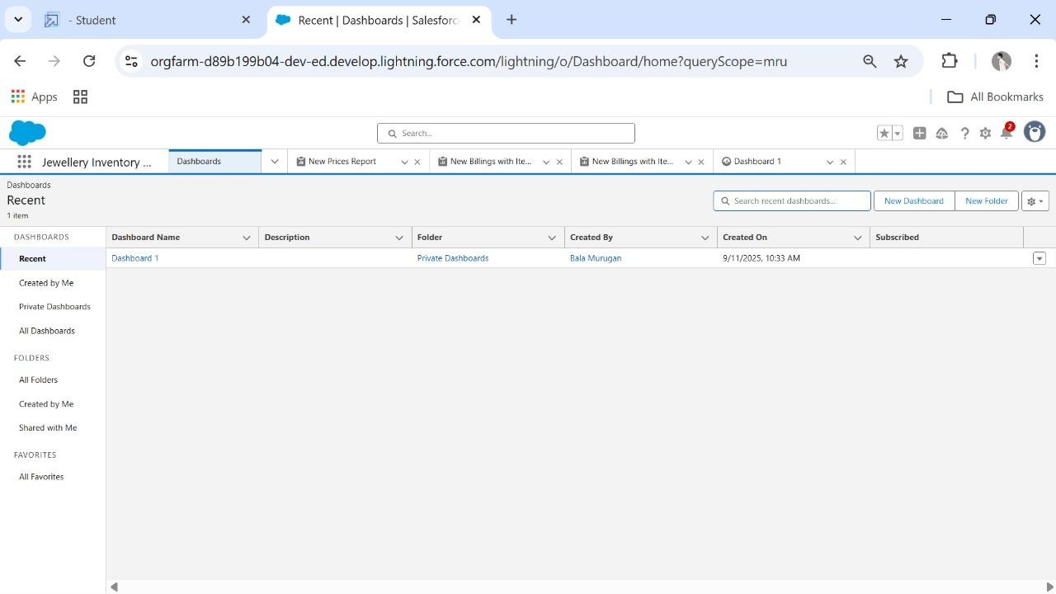

**Created Flows:**

**CONCLUSION:**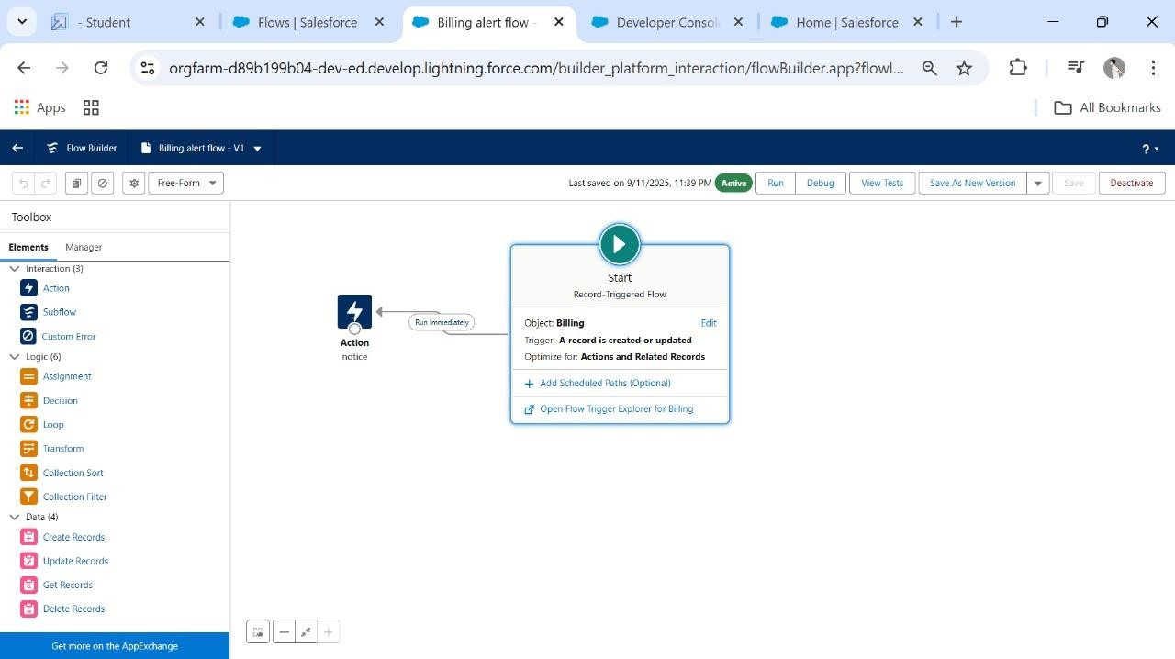

This project leverages Salesforce CRM to provide a cloud- based jewellery management system. It integrates customer relationship management with sales and inventory, helping jewellery businesses improve efficiency, profitability, and customer engagement.